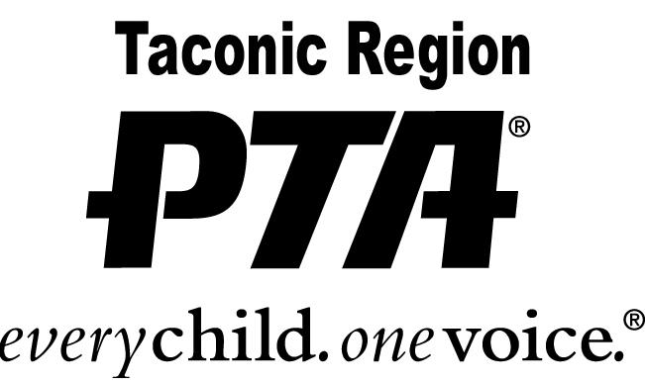

**UNSUNG HERO AWARD**

2021 – 2022 Application Instructions

PURPOSE:

This humanitarian award recognizes a student in grades six through eight who seeks to promote the welfare of others by showing kindness, integrity, tolerance, forgiveness, charity and volunteerism in his/her school, home, community and/or place of worship. The youth is an asset to the community and is self-motivated to help others without thought of recognition. He/She makes a difference in a quiet and untraditional manner.

\*\*\***This award is not presented for academic achievement**

CRITERIA:

1. Completed application.
2. A letter of recommendation which includes specific examples of how the nominee demonstrates the above humanitarian qualities in his/her daily life. This letter could be from one of the following: principal, teacher, staff member of the student’s school, coach, Sunday school teacher, scout leader or other community member.

DEADLINE:

The completed application and letters of recommendation must be postmarked or submitted by April 22, 2022.

MAIL TO: Christine Lent

Taconic PTA Awards Chairperson

24 Stonehedge Drive

Poughkeepsie, NY 12603

Questions: email Christine at awards@taconicpta.org