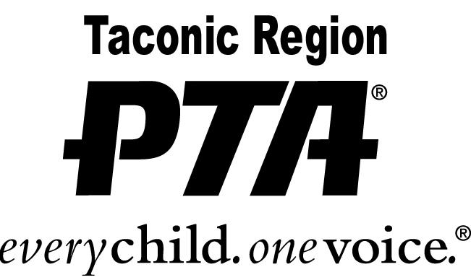

UNSUNG HERO AWARD
APPLICATION

Please print:

Nominee’s Name: ___________________________________________________

Current Grade: ______________

Address: ___________________________________________________________

Parent’s Name(s): ____________________________________________________

Phone #: home _______________________ cell ___________________________

PTA Unit / Council Name: ______________________________________________

PTA Code # 17 - __________

PTA Contact Person: __________________________________________________

PTA Position / Title: ___________________________________________________

Phone #: home ________________________ cell ___________________________

PTA President’s Signature:_______________________________________________

