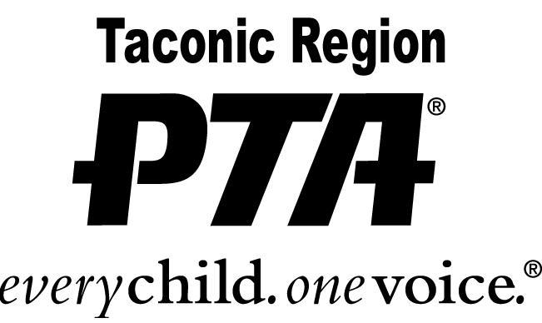

OUTSTANDING UNIT PROGRAM AWARD
2021 – 2022 Application Instructions

PURPOSE:
This award is given to promote and encourage the efforts of our PTA units. Good programs don’t just happen. They take time, effort, and a great deal of organization. They work when they meet the needs of students, staff and the community. Program planning with a purpose provides for good quality PTAs.

CRITERIA:
- Completed application.
- Give a brief summary of the program/event you are submitting and show how it:
  - Promotes the purposes of PTA
  - Embraces the interest of the entire membership
  - Encourages active participation of as many members as possible
  - Addresses a definite need or interest
  - Helps promote and strengthen home/school relationship
  - Should be a new/original concept (excluding PARP or other similar pre-existing programs)

DEADLINE:
The completed application and letters of recommendation must be postmarked by and submitted by April 22, 2022.

MAIL TO: Christine Lent
Taconic PTA Awards Chairperson
24 Stonehedge Drive
Poughkeepsie, NY 12603

Questions: email Christine at awards@taconicpta.org

